**CHAPTER 3: SYSTEM ANALYSIS**

* 1. **Requirements of New System:-**
     1. **Functional Requirement:-**
* Measuring the density of traffic
* Allotting time or modifying time for that lane.
* Reflecting the time at traffic signal.
  + 1. **Non-functional Requirement:-**
* Accuracy: System should display message or should alert end-user via buzzer on time. Or else Output should be shown or display on time.
* Consistency: Outcome of system should remain consistent after years also.
* Speed: System should process the data as fast as possible for sake of time integrity constrain.
  1. **Feasibility Study:-**
     1. **Does the system contributes to overall objectives of the organization?**

No, this is to be implemented as domestic product and it do save water and human efforts but does not contribute to overall objectives of the organization.

* + 1. **Can the system be implemented using the current technology and within the given cost and schedule constraints?**

Yes, this system can be implemented using current technology within given schedule but cost may increase.

* + 1. **Can the system be integrated with other system which is already in place?**

Yes, this system can be integrated where water supply is done at regular interval (domestic use), to save water at large scale.

* 1. **Block Diagram:-**

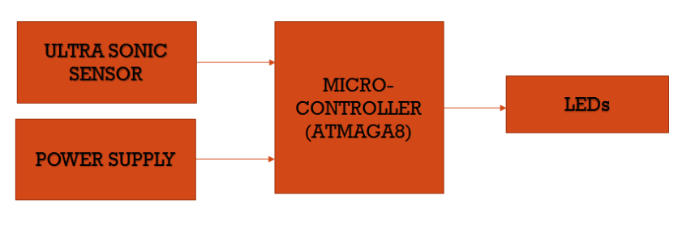

Fig 3.1

* 1. **Context Flow Diagram (CFD):-**

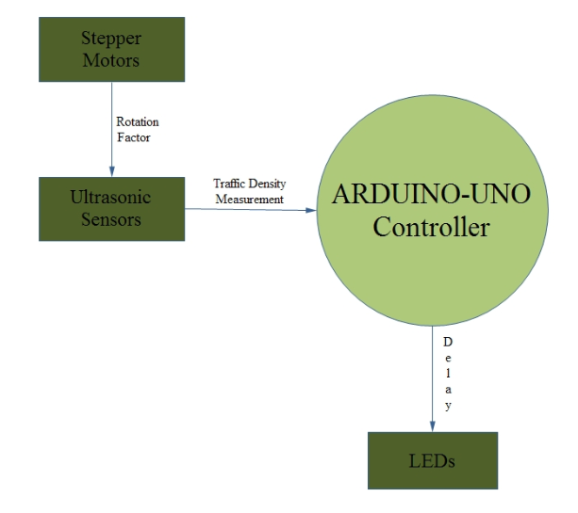

Fig 3.2

* 1. **Data Flow Diagram(DFD):-**

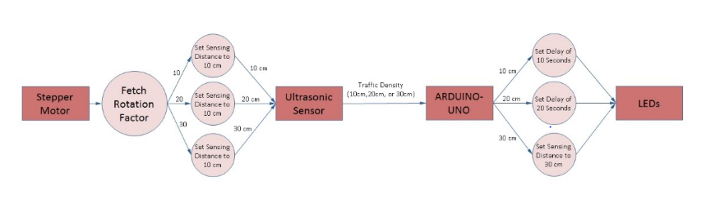

Fig 3.3